Group By

Server: Msg 8120, Level 16, State 1, Line 1  
Column 'xyz' is invalid in the select list because it is not contained in either an aggregate function or the GROUP BY clause.

Illogical

Suppose I ask you this:  "For each city in Massachusetts, what is the total number of residents and what is their age?"

|  |  |
| --- | --- |
| 752down voteaccepted | Group By X means **put all those with the same value for X in the one group**.  Group By X, Y means **put all those with the same values for both X and Y in the one group**. |

[Difference between PARTITION BY and GROUP BY](http://stackoverflow.com/questions/2404565/sql-server-difference-between-partition-by-and-group-by)

They're used in different places. group by modifies the entire query, like:

select customerId, count(*) as orderCount

from Orders

group by customerId

But partition by

 just works on [a window function](http://en.wikipedia.org/wiki/Select_(SQL)#Window_function), like row_number:

select row_number() over (partition by customerId order by orderId)

as OrderNumberForThisCustomer

from Orders

A group by normally reduces the number of rows returned by rolling them up and calculating averages or sums for each row. partition by does not affect the number of rows returned, but it changes how a window function's result is calculated.

**window function**

* [Ranking functions](https://msdn.microsoft.com/en-us/library/ms189798.aspx)
* [Aggregate functions](https://msdn.microsoft.com/en-us/library/ms173454.aspx)
* [Analytic functions](https://msdn.microsoft.com/en-us/library/hh213234.aspx)
* [NEXT VALUE FOR function](https://msdn.microsoft.com/en-us/library/ff878370.aspx)

Ranking Function

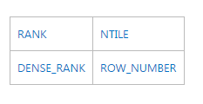

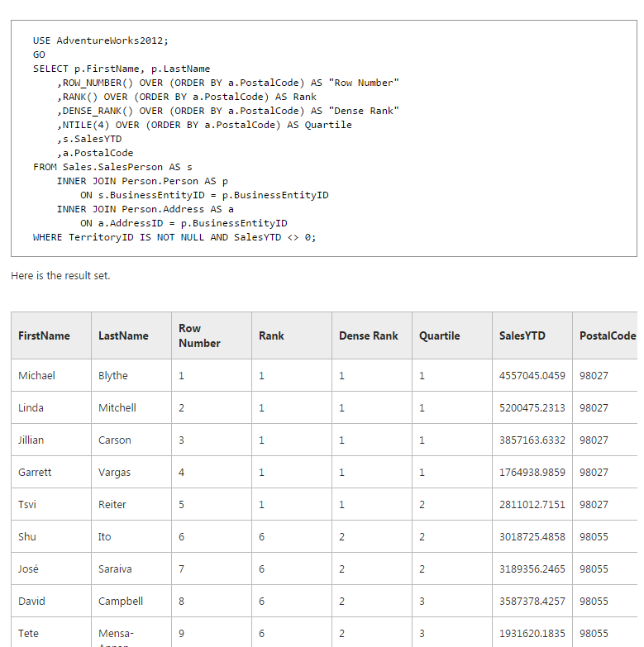

Aggregate Functions (Transact-SQL)

Aggregate functions perform a calculation on a **set of values and return a single** value. **Except for COUNT, aggregate functions ignore null values**. Aggregate functions are frequently used with the GROUP BY clause of the SELECT statement.

All aggregate functions are deterministic. This means aggregate functions return the same value any time that they are called by using a specific set of input values. For more information about function determinism, see [Deterministic and Nondeterministic Functions](https://msdn.microsoft.com/en-us/library/ms178091.aspx). The[OVER clause](https://msdn.microsoft.com/en-us/library/ms189461.aspx) may follow all aggregate functions except GROUPING and GROUPING_ID.

Aggregate functions can be used as expressions only in the following:

* The select list of a SELECT statement (either a subquery or an outer query).
* A HAVING clause.

Transact-SQL provides the following aggregate functions:

|  |  |
| --- | --- |
| [AVG](https://msdn.microsoft.com/en-us/library/ms177677.aspx) | [MIN](https://msdn.microsoft.com/en-us/library/ms179916.aspx) |
| [CHECKSUM_AGG](https://msdn.microsoft.com/en-us/library/ms188920.aspx) | [SUM](https://msdn.microsoft.com/en-us/library/ms187810.aspx) |
| [COUNT](https://msdn.microsoft.com/en-us/library/ms175997.aspx) | [STDEV](https://msdn.microsoft.com/en-us/library/ms190474.aspx) |
| [COUNT_BIG](https://msdn.microsoft.com/en-us/library/ms190317.aspx) | [STDEVP](https://msdn.microsoft.com/en-us/library/ms176080.aspx) |
| [GROUPING](https://msdn.microsoft.com/en-us/library/ms178544.aspx) | [VAR](https://msdn.microsoft.com/en-us/library/ms186290.aspx) |
| [GROUPING_ID](https://msdn.microsoft.com/en-us/library/bb510624.aspx) | [VARP](https://msdn.microsoft.com/en-us/library/ms188735.aspx) |
| [MAX](https://msdn.microsoft.com/en-us/library/ms187751.aspx) |  |

# COUNT

Returns the number of items in a group. COUNT works like the [COUNT_BIG](https://msdn.microsoft.com/en-us/library/ms190317.aspx) function. The only difference between the two functions is their return values. COUNT always returns an **int** data type value. COUNT_BIG always returns a **bigint** data type value.